PowerPoint mapping
Software required: GIS software and MS PowerPoint
- Load a simple and plain boundary map in the GIS Software (ArcGIS), preferably showing the boundaries the user wants to show.
- Zoom in or pan to the desired area
- Label the features
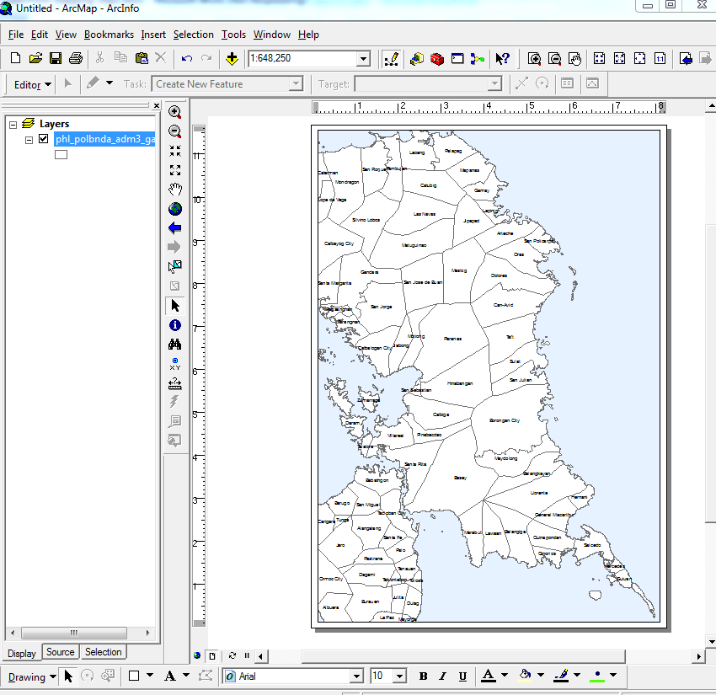
- Export map in Enhanced Metafile image (.emf) file format
- Insert .emf image file in MS PowerPoint
- Each polygon feature including the labels in the map can now be manipulated in terms of color or shade depending on the desired presentation
- Here is a sample of PowerPoint mapping for the Philippines (by MapAction) https://www.humanitarianresponse.info/operations/philippines/document/mapping-powerpoint-community-templates-mapaction

