OSOCC ASSESSMENT + ANALYSIS Cell

This annex to the UNDAC Handbook describes the purpose of the OSOCC Assessment and Analysis (A+A) Cell, its main activities, outputs and available tools. It also provides brief guidance on the appropriate set-up, pending on the size of the emergency and the capacity of the deployed UNDAC team. Below recommendations are not mandatory, rather they should be used where appropriate to help achieve the aim of the A+A Cell and to ensure an effective Situation Function.

OSOCC Standard Organigram:
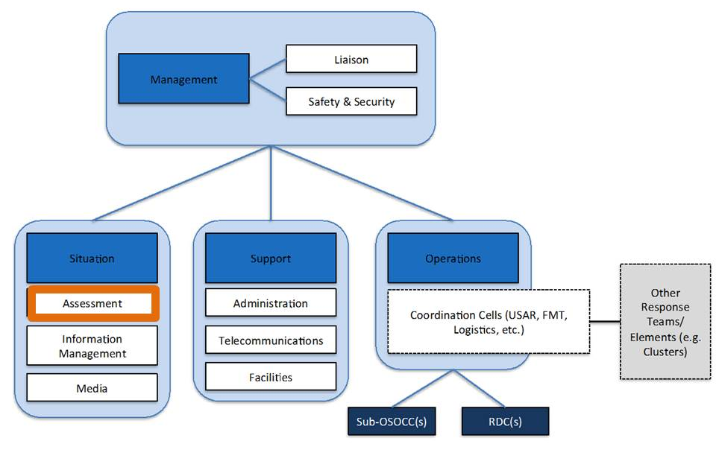

- Purpose OSOCC A+A Cell:

- To produce a regularly updated synthesis of the humanitarian situation in order to support analysis of the humanitarian situation, in particular current and forecasted humanitarian needs, priority areas, groups and sectors, and gaps
- Support OSOCC management (and Humanitarian Coordinator as required) in developing an operational picture of the humanitarian situation and inform multi sectoral strategic decision making
- Facilitate among humanitarian partners (government, agencies, clusters, NGOs etc.) a shared understanding of humanitarian situation

2. Main tasks

- Manages external coordination of assessments and analysis with clusters, agencies and the government, e.g. through the establishment and facilitation of an assessment working group (AWG) and participation at cluster and INGO coordination meetings.
- Manages the internal consolidation of information and coordination of analysis with other OSOCC functions (management, operations) and its cells (information cell, mapping, Civ-Mil, EMT, sub-OSOCCs) and the RC/HC’s Office as required.
- Produces regular situation analysis reports/briefings and the outputs specified in paragraph 4, below in consultation with other functions and the RC/HC’s Office as required. Work closely with mapping team (e.g. MapAction).
- Leads secondary data analysis (the review of secondary data might be supported remotely, pending on the cell’s set-up and available remote capacity).
- Coordinates field assessments (primary data collection).
- Leads the MIRA process, when initiated.
- Manages external communication (through email, webcontent and meeting participation) on analysis and assessments in consultation with the OSOCC management.

3. Setup

Pending on the size of the emergency, the UNDAC team and the OSOCC, the setup of the A+A Cell will vary. While assessment cell teams will have to be flexible with regards to how roles are distributed or bundled it is important to clearly assign functions within the cell:
- For medium sized emergencies (type L2) it is recommended to have at least two persons assigned to the Cell, one assessment coordinator in charge of managing the Cell, the coordination of assessments and liaison with partners, and one person, ideally sheltered from the daily coordination activities, focusing on collation of pre- and in-crisis secondary data and analysis.
- For larger emergencies (type L3) a minimum of three persons, ideally four, should be assigned to the Cell assisted by volunteers supporting the gathering, consolidation and analysis of secondary data: One assessment coordinator managing the Cell and coordination with partners and other cells; one person overseeing the secondary data process and analysis; one person managing the coordination of of primary data collection; and one dedicated IM person in charge of data management, liaison with IM remote support partners (e.g. Digital Humanitarian Network), mapping and infographics.
- Remote support: Independent of the capacity on the ground, the A+A Cell should be supported remotely as best possible. Support may include liaison with global partners (UNOSAT, ACAPs, Digital Humanitarian Network, etc.), secondary data review and analysis.

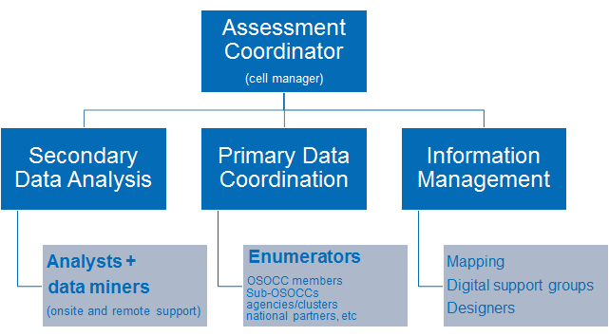

4. Outputs of A+A Cell

Below is a list of recommended outputs. Each output is explained in more detail in the A+A Cell toolbox. Pending on the capacity and setup of the A+A Cell some outputs will need to be prioritised.

Products:
- Periodic situation analysis (analytical overview of current situation)
- Daily briefing packages (for Humanitarian Coordinator and coordination meetings as required)
- Caseload estimations + Humanitarian profile (analytical note detailing estimates of humanitarian population figures)
- Geographic profiles (analytical overview of affected districts, disaster zones or livelihoods zones)
- Assessment Coverage maps (geographic visual of assessment registry illustrating where assessments have taken place, ideally broken down by sector).
- Assessment reports (of direct observations or MIRA type assessments conducted by the UNDAC team and partners)
Data management and information tools
- A+A Cell webspace (site where products, reports, contacts, meeting schedule and the assessment registry is hosted e.g. on HR.info or V-OSOCC)
- Assessment Registry (table or database of conducted and planned assessments tagged by date, organisation, location and sectors, with links to reports, ideally hosted on a website, e.g. HR.info)
- Database with pre-crisis (population, demographic breakdown, poverty data, lessons learned) and in crisis data tagged by problem type, location, severity, reliability, date, relevant analytical categories, sector, vulnerable groups and source (a template is provided in the toolbox)
- Database visuals

5. Tools

These are examples of tools to support the activities of the A+A Cell. Please consult the A+A toolbox for more detail:
- Secondary data review tools (database and spreadsheet templates, HDX)
- Standard questionnaires (Direct Observation, key informant, focus group discussion) including guidance
- Analysis modules for primary data collection (enumerator debriefs, district summary sheets)
- KoBo
- Assessment registry (HR.info)
- PPt maps
- Sample TORs Assessment working group
- Office box (email account, A+A website instructions), etc

6. Transition of A+A Cell (exit strategy)

In most contexts ongoing needs analysis will be required beyond the UNDAC life cycle. In this case, efforts should be made to plan for a seamless transition. Following options will have to be considered:
- If OCHA is present it will take on the coordination functions established by the OSOCC and the A+A cell should be managed by the OCHA Assessment Coordinator. It is likely that with the departure of UNDAC the capacity of the A+A Cell will be reduced. In this case the OCHA Assessment Coordination will have to prioritise the tasks.
- In absence or phase down of OCHA capacity, the A+A cell could be transferred to the RC’s office. Capacity will likely be smaller requiring a prioritisation of assessment related tasks
- In absence of any UN capacity, the cell and its tool should be transitioned to the host government. This should be accompanied by appropriate capacity building

This annex refers to the OSOCC Assessment and Analysis cell to emphasize that coordinating assessments is but one activity within the broader function of situation analysis
TORs for an AWG are included in the A+A Cell’s toolbox

